

Light following robot without any microcontroller



The IOT Academy

Experiment 1:-
To design and construct a simple robot that follows a light source using one LDR, one relay module, and two DC motors — without the use of any microcontroller.

Material required :-
MY

Component | Quantity
LDR (Light Dependent Resistor) | 1
DC Motors (Geared or Simple) | 2
Relay Module (SPDT, 5V/6V) | 1
NPN Transistor (e.g., BC547) | 1
Resistor – 10kΩ | 1
Resistor – 1kΩ | 1
Flyback Diode (e.g., 1N4007) | 1
Breadboard | 1
Jumper Wires | As required
Castor Wheel | 1
Robot Chassis or Base Plate | 1
6V or 9V Battery + Clip | 1
Tape, Glue, Screws | As required

Circuit Description:
E
C
THE IOT A
AD

- The LDR and a 10kΩ resistor form a voltage divider.

- The voltage from this divider controls the base of an NPN transistor (e.g., BC547).

- When light intensity increases, the LDR's resistance decreases, increasing base voltage and switching on the transistor.
- The transistor energizes the relay, which switches motor power between the left and right motor.
- Based on light intensity, either the left or the right motor is powered, causing the robot to turn toward the light source.

Procedure:

Mounting:
    - Attach the two DC motors to either side of the chassis.

    - Add the castor wheel for balance.
    - Secure the LDR facing forward (toward the light source).

Building the Circuit:
    - Connect the LDR in series with a 10kΩ resistor to form a voltage divider.
    - Connect the midpoint of the divider to the base of the NPN transistor through a 1kΩ resistor.
    - Connect the collector of the transistor to one side of the relay coil.
    - Connect the other side of the relay coil to +Vcc.
    - Place a flyback diode (1N4007) across the relay coil (cathode to Vcc).
    - Connect the emitter of the transistor to GND.
    - Connect the relay’s COM pin to the battery positive.
    - Connect the NO and NC pins of the relay to the right and left motor terminals respectively.
    - Ground the other terminals of both motors.

Power On:
THE IOT ACADEMY
    - Connect the battery (6V–9V) to the circuit.
    - Direct a flashlight or bright light source at the LDR and observe the robot movement.
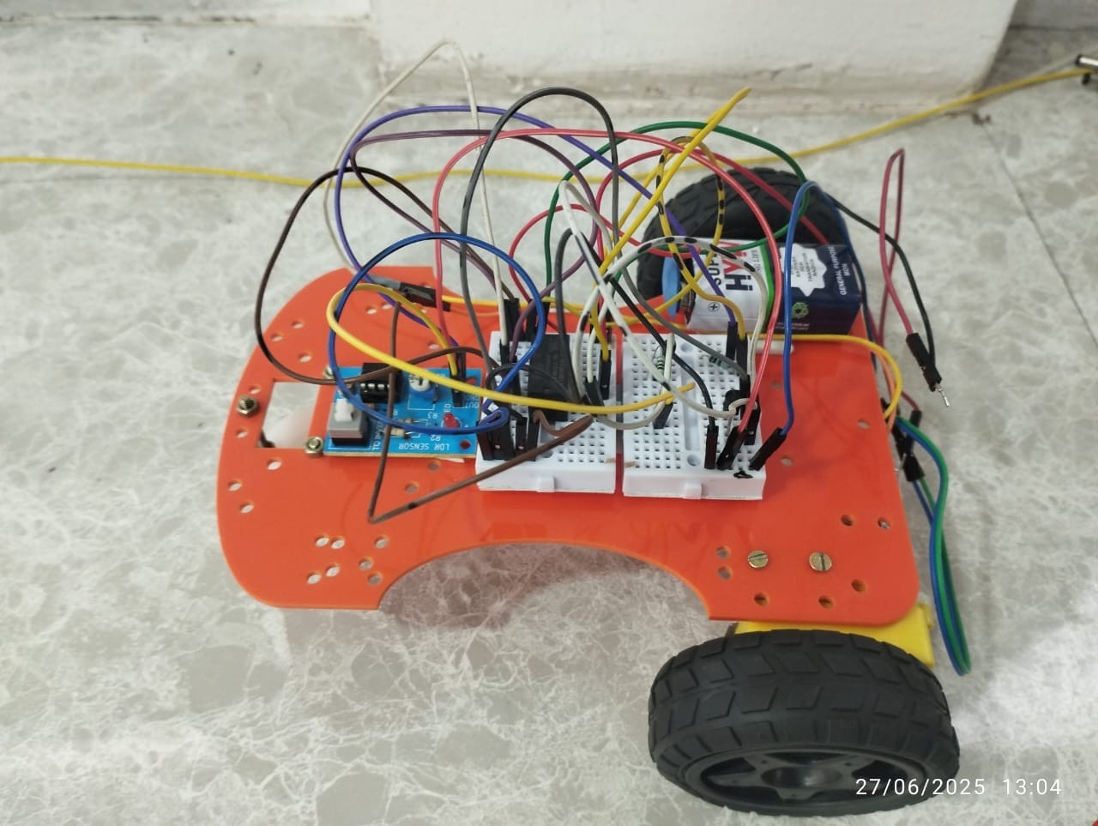
PICTURE OF LIGHT FOLLOWING ROBOT :-

Component pic:-

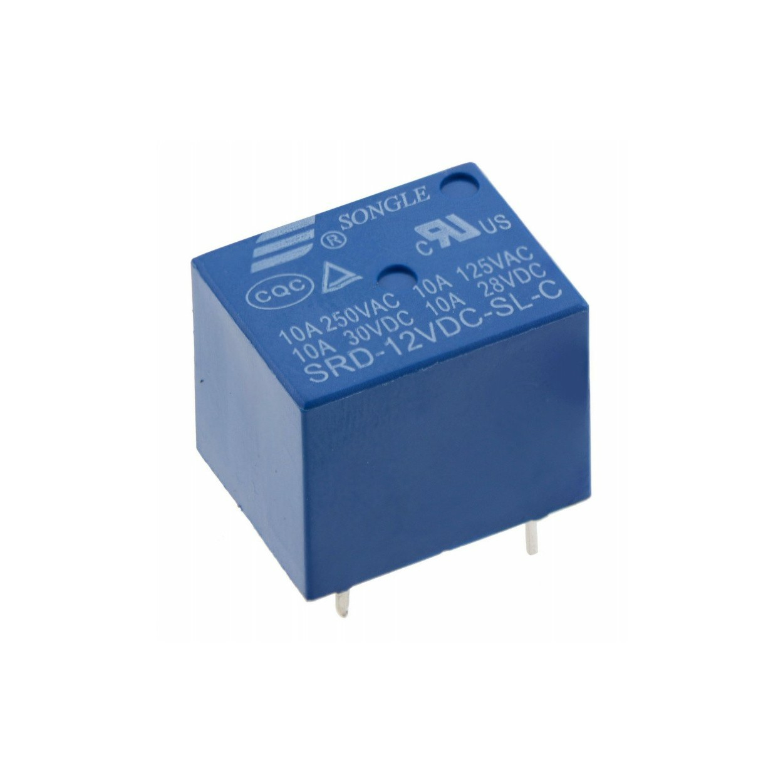
Dc motor Relay
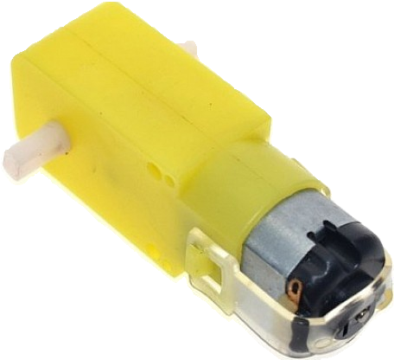

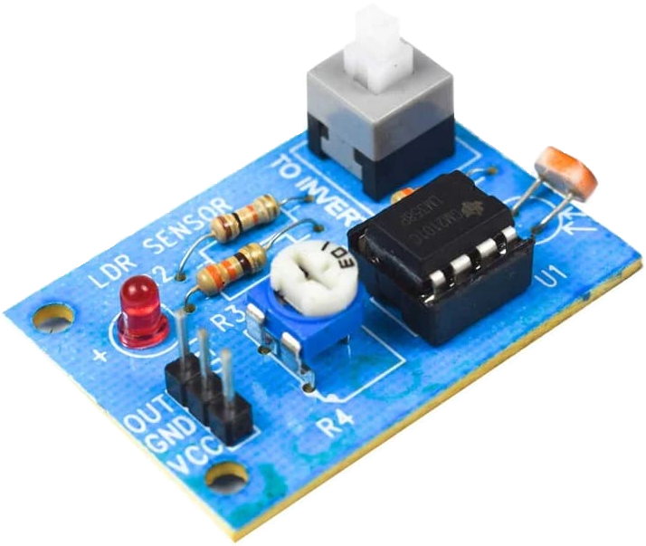
Jumper wire
Ldc sensor

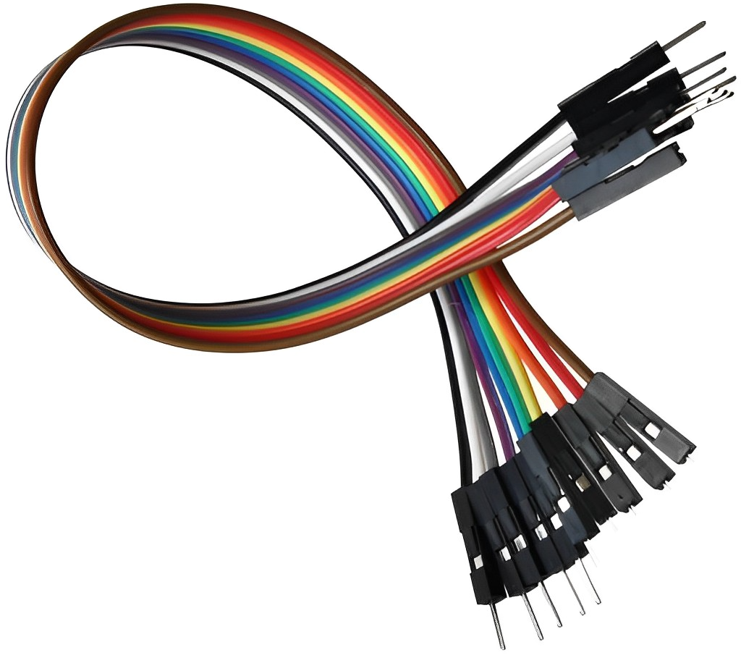

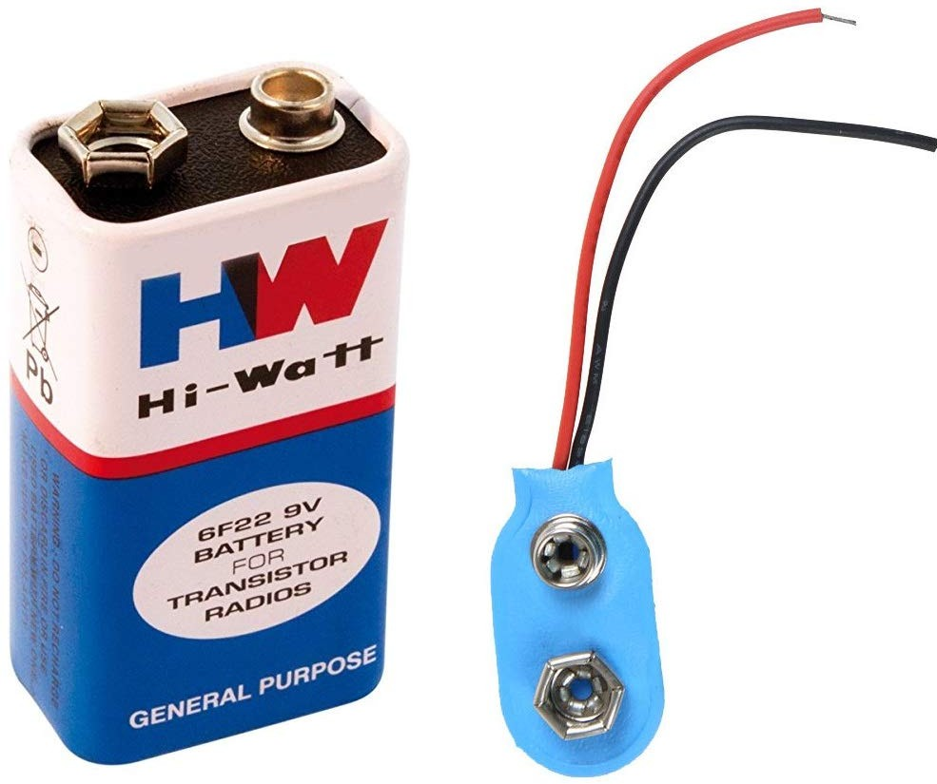
Castor wheel bread board

Battery

THE IOT ACADEMY

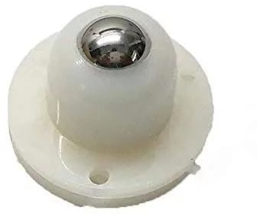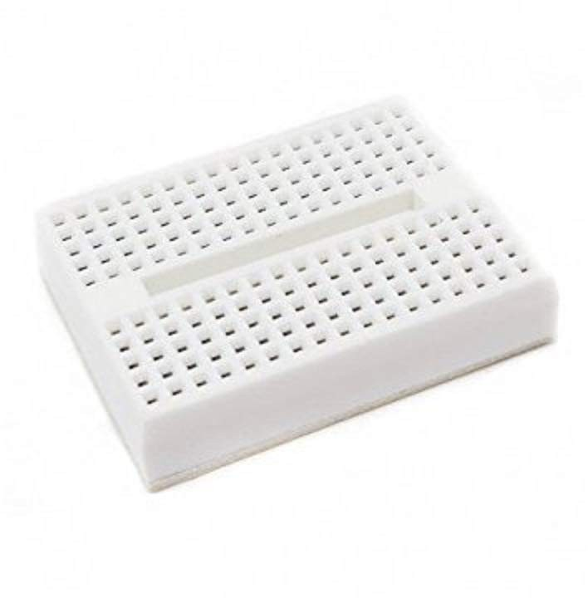

Pin Configuration & Connections
EMY

Component | Pin/Terminal | Connection
LDR | One end | +Vcc
 | Other end | To 10kΩ resistor and 1kΩ (Voltage Divider)
10kΩ Resistor | One end | GND
 | Junction with LDR | To base of transistor via 1kΩ resistor
1kΩ Resistor | One end | LDR + 10k junction
 | Other end | Base of NPN transistor
NPN Transistor | Base | From 1kΩ resistor
 | Collector | To one end of Relay Coil
 | Emitter | GND
Relay Coil | One end | To Collector of NPN
 | Other end | +Vcc
Flyback Diode | Cathode (strip) | To Vcc
 | Anode | To Collector (Relay side)
Relay (Switch Side) | COM (Common) | Battery Positive Terminal
 | NO (Normally Open) | Right Motor Terminal
 | NC (Normally Closed) | Left Motor Terminal
Motors | Right Motor Other End | GND
 | Left Motor Other End | GND

Observation Table:
D
T
THE IO
ACA

Light on LDR | Relay State | Motor Running | Robot Direction
No light | OFF | Left motor | Turns right
Bright light | ON | Right motor | Turns left
Moderate light | Fluctuates | Fluctuates | Wiggles forward

Result:
The robot successfully followed the direction of a light source by switching between motors using a single relay, one LDR sensor, and basic components — without any microcontroller.

Conclusion:
THE IOT ACADEMY
This experiment demonstrates how basic electronics components such as LDRs, transistors, and relays can be used to mimic intelligent behavior in robots. The light following behavior was achieved by controlling motor direction based on the intensity of light falling on the sensor. No microcontroller or programming was required.

